

BICT.Honours in Information & Communication Technology

ICT1222 (P) Database Management Systems Practicum

Level 1- Semester 2 | 2022

Lecturer : Ms. Malsha

**Practical 02 Excercises**

Name : H.P.G.L.P. Jayathilake

Student No : TG/2020/749

Department of Information & Communication Technology

Faculty of Technology

University of Ruhuna, Sri Lanka.

FACULTY OF TECHNOLOGY

UNIVERSITY OF RUHUNA

ICT1222 (P) Database Management Systems Practicum

**Practical 02 Exercises**  Level 1- Semester 2 | 2022

Student No: **TG/2020/749**

Student Name: **H.P.G. Lahiru Prasad Jayathilake**

1. **Create the database “mytestDB”.**

1. **Show the available databases.**

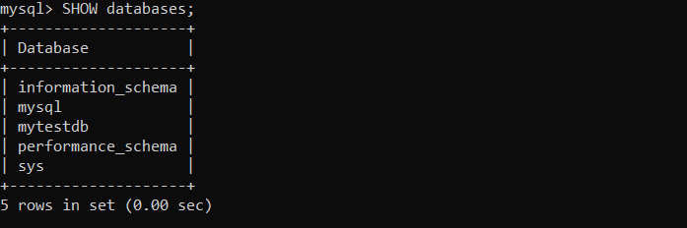

1. **Use the above created database “mytestDB”..**

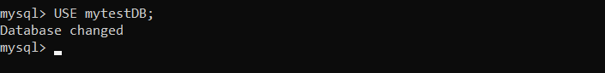

1. **Create users for the “mytestDB” database as follows.**

**a) admin_ict with ALL privilages**

**b) Teacher with SELECT,INSERT,UPDATE,DELETE**

**c) Student with SELECT**

**d) Subject_user with All privileges.**

1. **Show the privileges given to Teacher.**

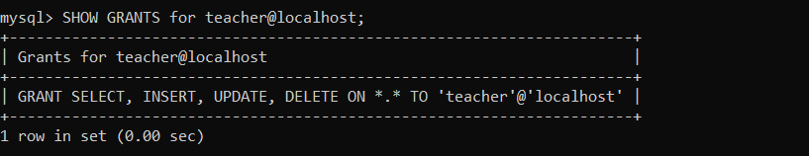

1. 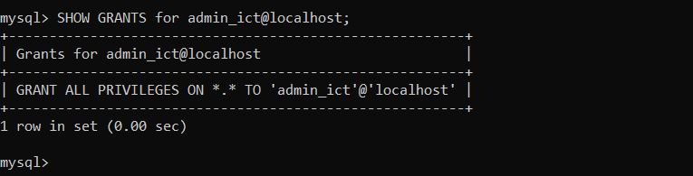**Show the privileges given to admin_ict.**
2. **Delete the user Subject_user.**

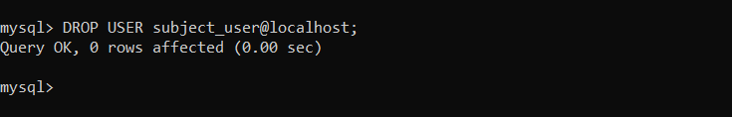

1. **Create following tables in the above database..**

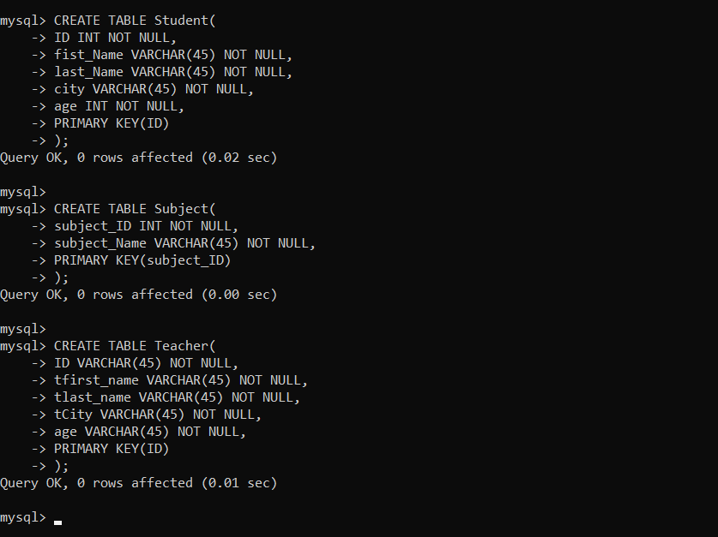

1. **11. Show the table structures**

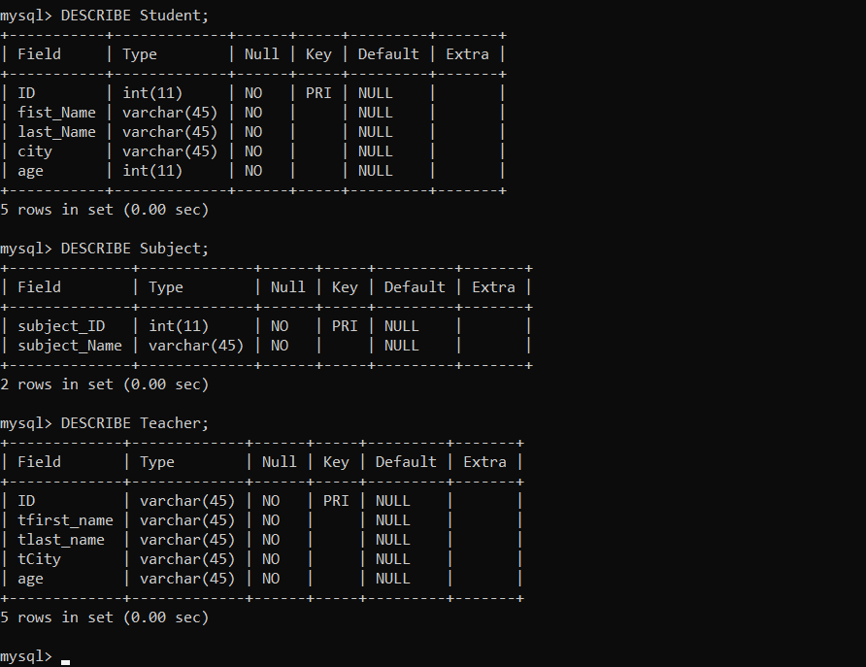

1. **Insert following data into above created three tables..**

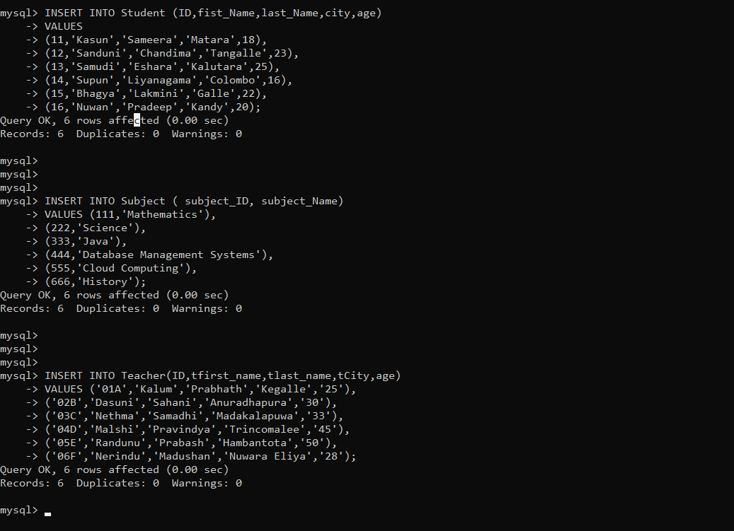

1. **Write a select statement to retrieve all the data from Student table**
2. **Write a select statement to retrieve all the data from Subject table**
3. **Write a query to retrieve ID and first name of the students**

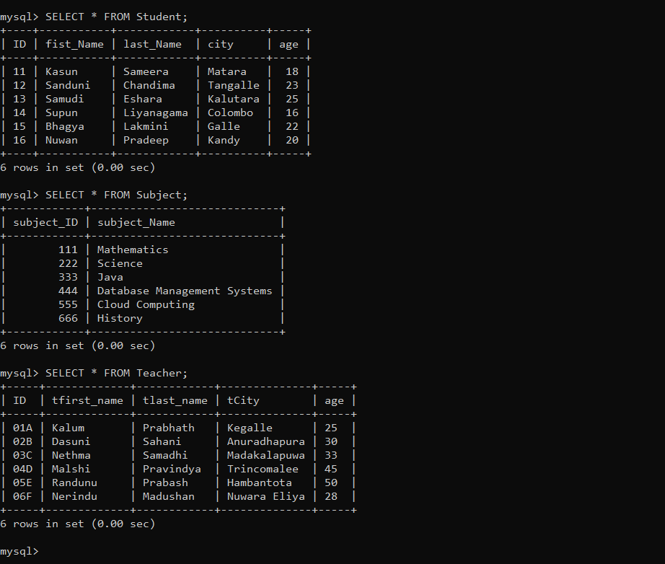

1. **Write a query to retrieve ID and first name of the students**

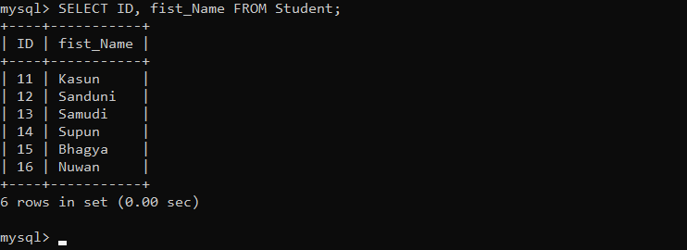

1. **Write a query to retrieve ID, first name and city of teachers**

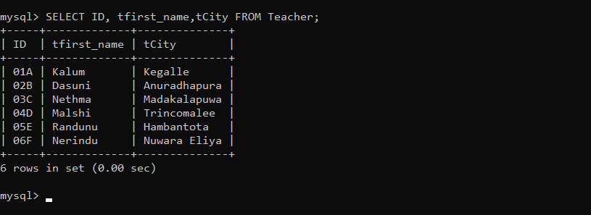

1. **Write a query to remove the table ‘Teacher’**

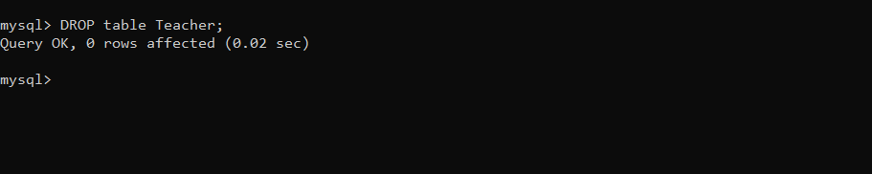

1. **What is the use primary key?**

* **A primary key** is essential if a table is to qualify as a relational table. It is made up of one or more columns whose data uniquely identifies each row in the table. For example, if the data in the rows contained house numbers, the primary key could be used to identify the streets on which the houses were situated. To qualify as a primary key, it is the data within each column that must be unique, not simply the column names themselves.  At the same time, no value in the columns can be blank or NULL.

1. **Name the primary keys of each created tables above. ?**

* Student Table- ID.
* Subject Table- subject_ID.
* Teacher Table- ID.